Things I’m good at
- I have
- I can
Things about me
- I am
How I communicate
- I use




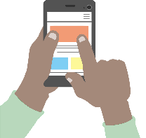

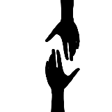

Tricky things/ Challenges
- I don’t like
- It’s difficult for me
- I need you to help me
- I’m still working on
My favourite things
- I like

Things that help me
- It helps me if you






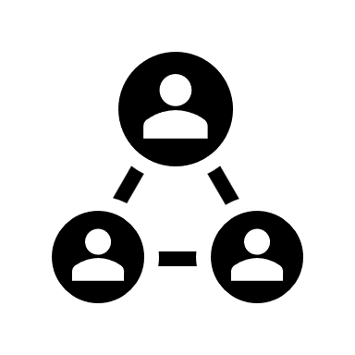

Replace with photo
More things you need to know about me

Important people

If you want to find out more about Passports, look up www.communicationpassports.org.uk


If you want to find out more about Passports, look up www.communicationpassports. org.uk

Hi, I’m
X
- I’m x years old
- I live in x
- Family…
- Pets…

